MARKER PLACEMENT GUIDE

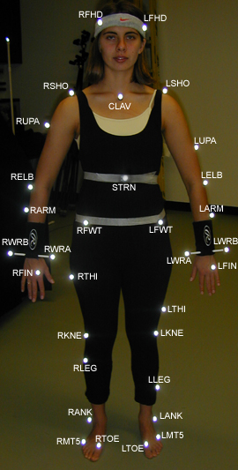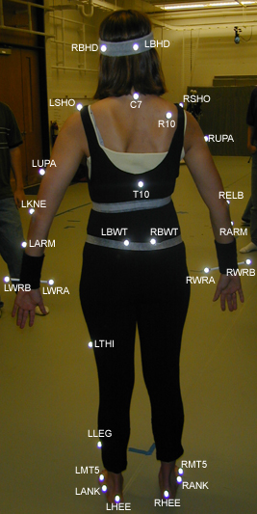

The marker placement in this document is only one of many possible combinations. This guide will only show the standard marker placement that’s being used in the motion capture laboratory. The marker placement in this guide resembles the one that is shown and explained in the Vicon 512 manual. As such, the Vicon 512 Manual can offer additional information. The difference with the marker set in this document from the Vicon 512 Manual is the addition of 4 markers, namely RARM, LARM, RLEG, and LLEG.

Before starting, below are some general rules of thumb one should follow:
- Have the person who’s going to be motion captured wear tight fitting clothes—strap down any areas of the clothing that is loose. The marker balls’ position should move as little as possible and should be properly seen.
- Place the marker balls as close to the bone as possible. This follows the rule of having the marker balls stay stationary during movement.
- To help the motion capture system distinguish the marker balls the left side and the right side of the body, place marker balls asymmetrically when appropriate. For example, the RTHI and LTHI, as shown in the picture above, are placed asymmetrically from each other.
- If a marker ball is placed improperly and one decides to reposition it before the motion capture begins, replace the tape of the said marker ball with a fresh tape to make sure the marker ball will stay put. If a marker ball falls off during the motion capture, one has to recalibrate the subject and redo the motion capture in order to get accurate results.
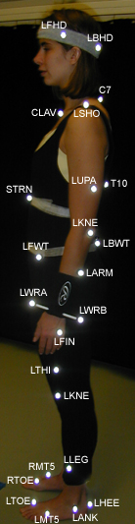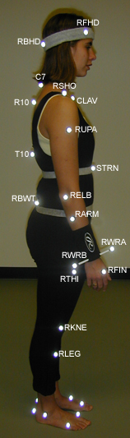

Head and Wrist

There are head bands and wrist bands with marker balls attached provided. Have the subject wear them with the sign facing forward.

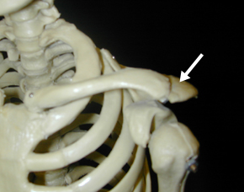
Shoulders

Place the marker ball on the shoulder bone of the subject. To find the shoulder bone, have the subject move his or her arm up and down and find the area of the shoulder that doesn’t move when the arm is moved up and down.

Do the same for both sides.

Clavicle

The marker ball for the clavicle should be placed in between the two collar bones and below the base of the neck.

Elbow

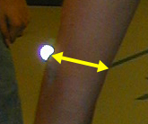
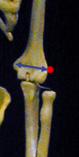
Find the area where the upper arm and forearm connect. Place the marker ball above the area of the upper arm’s bone that connects to the forearm’s bone. The marker ball should be place along the line connecting the upper arm’s bone from one side to the other. Make sure the marker ball doesn’t move when the arm is bent up and down. Do the same for both sides.

Left Hand

Put the marker ball on the base of the ring finger.

Right Hand

Put the marker ball on the base of the index finger

Upper Arm

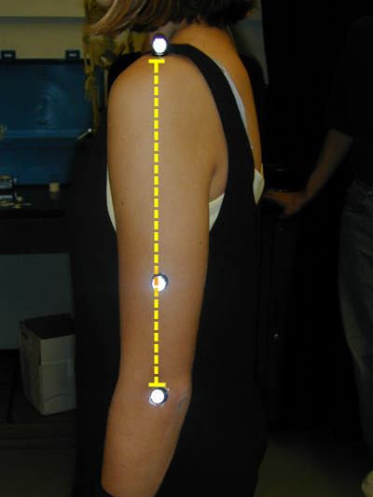
Place the marker ball for the upper arm somewhere along the line that connects the marker ball on the shoulder and the marker ball on the elbow.

Place the marker ball asymmetrically on the other arm.

Forearm

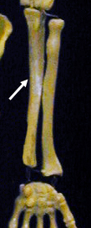
Place the marker ball for the forearm on the outer edge of the forearm, preferably near the edge of the outer bone of the forearm.

Put the marker ball on the other forearm asymmetrically.

Sternum

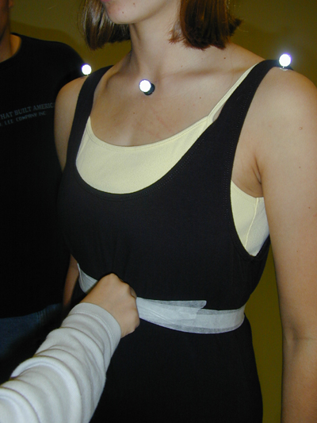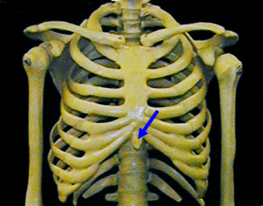

Put the marker ball on the base of the middle of the ribcage. For women, the marker ball is placed below the breast so it is advisable to tape down that area in order to keep the marker ball unobstructed.

C7

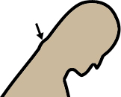
Have the subject bend his or head down. The C7 bone is located along the spinal column right where the back of the neck ends. A small bone jutting out will indicate that. Put the marker ball right on the bone.

T10

The T10 is also located along the spinal column. Count 10 vertebrae down from C7 and place the marker ball on the 10th vertebrae.

To better see and feel the spinal column, have the subject bend down and push his or her shoulders inward.

Pelvis

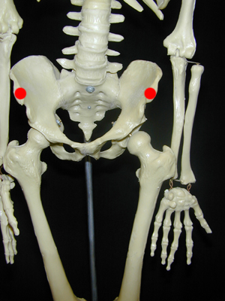
Put the marker balls on the area of the pelvis bone that juts out the most. The figure on the left shows where this is located.

Back Waist

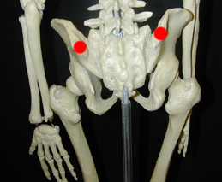
At the back of the pelvis bone, there are two more areas that jut out a little. Place the marker balls on these areas. This is located at the base of one’s back and right before the buttocks start.

Foot

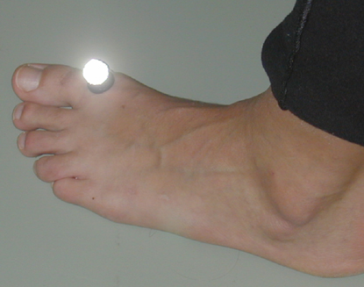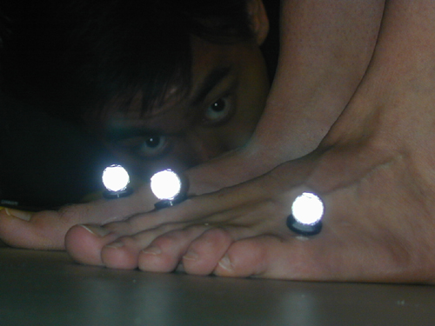

For each foot, put a marker ball on the bone right before the toe starts. Put another marker ball on the outer edge of the foot on the bone right before the pinky toe starts.

Ankle
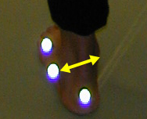
The same with the elbow, put the marker ball along the line that connects the opposite sides of the ankle bone.

Heel

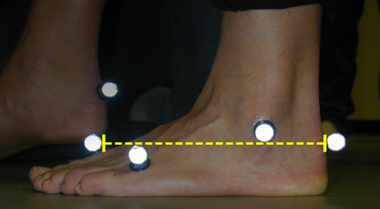
The marker ball for the heel should be placed on the heel bone and it should be placed such that the line connecting the toe marker ball and heel marker ball is parallel to the ground.

Knee

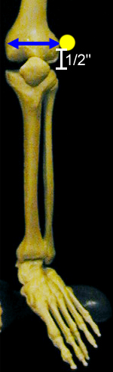
Have the subject swing his or her lower leg back and forth. Find the lowest area of the upper leg that doesn’t move when the lower leg is swung back and forth. This corresponds to the bone right above the ball joint of the knee. Place the marker ball about ½” above the break between the upper and lower leg. The marker ball should also be placed along the line that connects the opposite sides of the upper leg’s bone. Make sure the marker ball doesn’t move when the lower leg is swung back and forth.

For women, the marker balls must be place more to the front than usual. More masculine subjects should have marker balls put a little more to the back since the muscle of the legs may move the marker balls during movement.

Thigh

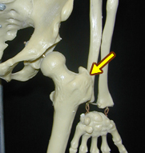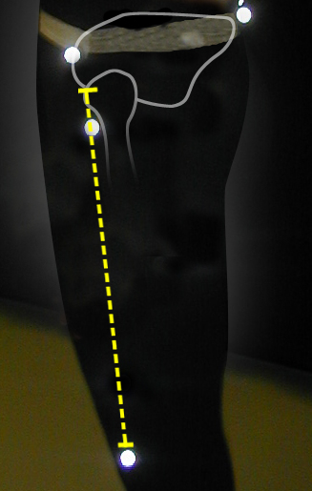

Find the area of the femur that juts out the most to the side of the body. This should be located somewhere below the pelvis. The marker ball should be placed along the line that connects the said area of the bone and the knee marker ball.

Place the marker ball asymmetrically on the other thigh.

Leg
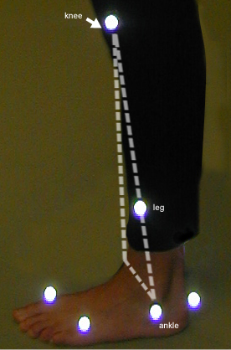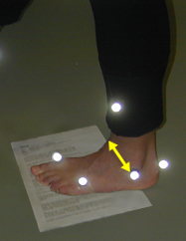

Visualize a triangle that connects the knee marker ball, the ankle marker ball and the opposite side of the ankle bone. The marker ball should be placed along the line that connects the knee marker ball and the ankle marker ball.

To help the person putting the marker ball visualize the line connecting the ankle marker ball and the opposite side of the ankle bone, put a paper under the subject’s feet such that the edge of the paper lines up with the line connecting the ankle marker ball and the opposite side of the ankle bone. The person might want to ask help from the subject because the best vantage view for visualizing the three lines is directly above the subject’s leg.

